**SENDIASS Telford and Wrekin**

**CONTRACT REPORT**

**Quarter 4 – January/March 25**

**1 July – 30 September 2022**

report

**Report Highlights**

The spotlight this quarter has again been on our children and young people. Our joint working with the Telford Childrens Autism hub has continued to support the development of participation of Young People to give a voice to what is important to them. We have listened to young people and the Elevate Youth Project “**Independence Me**” has been a real focus since January. The group have been involved in all aspects of this project. They have discussed the areas of support that would be important in increasing their confidence, supporting their aspirations as they are moving into adulthood. The sessions began with a 4-week programme at our Madeley Community Café . The young people were involved in budgeting, sourcing ingredients, shopping, cooking and sharing the food together. The young people have also been given the opportunity to complete their Food hygiene qualification, and they are in the process of completing this.

It was lovely to see the young people working as a team, interacting with each other and socialising in a safe place.



**Referrals**

The Team have dealt with a very high number of referrals more than double the previous quarter. There has been a high level of contacts to the service, via, email, telephone and website.

The team continue to upskill themselves on the new database. There has been a need for the whole staff team to use the supports in place to enable them to navigate the changes. Staff are ensuring that where there are still any gaps in the data that they themselves are adding relevant fields to ensure the data is fully available and accessible. As the organisation continues to develop the teams in ongoing training and upskilling in this area there is real potential for utilising some of the features that will allow for increased access to good quality data.

Themes as reflected by a member of staff:

***I have taken many calls on triage this quarter and within the theme of SEN Support, communication is one area that is coming to the front along with the removal of provision.***

***Provisions includes access to the pastoral base and reasonable adjustments which are meant to help remove barriers to learning.***

***For example, I’ve experienced many calls from parent carers who C/YP attends Burton Borough School. Parent carers say they either can’t get a meeting, or the provision that was supporting their C/YP has been just taken away.***

***Many of these families have attended our Sen Bitesize Sessions and due to the circumstances have decided to apply for a Parent Request EHC Needs Assessment.***

***I have taken comments to our YP case worker Maria and she is in the process of reaching out to the school to discuss further.***

**Referrals**

**157**

**To date**

**348**

**358**

**r to Date**

**443**

**34**

**To Date 178**

**Closures**

**29**

**Service Contacts**

**Tier 1 Information, Advice, Signposting**

**115**

**Tier 1 Information, Advice Signposting**

**8**

**Tier 3 More detailed IAS, EHCP Process**

**128**

**Tier 3 More detailed IAS, EHCP Process**

**47**

**Tier 2 SEND Support, Workshops**

**39**

**Tier 2 SEND Support, Workshops**

**118**

**Tier 4 More complex Info, Keyworker Appeal Process, Mediation**

**57**

**Tier 4 More complex Info, Keyworker Appeal Process, Mediation**

**109**

**Current Quarter**

**Year to Date**

**Service Levels of Intervention**

**Summary of Service Levels of Intervention**

At Year end we can see from the Tier Framework that over the year there has been a move toward parents who are requiring more specific and detailed information, advice and support with a keyworker approach. This level of need and complexity that we are seeing has been a challenge to the team in managing the need. As previously highlighted we have weekly triage meetings, and where possible we allocate cases requiring a more personalised support. However the majority of parents are accessing support , particularly in relation to appeals, and complex EHCP support through individual advice sessions, signposting to our website, via our webinars, and any opportunities to attend key workshops where is there is a collective need. We are also seeing parents at our community drop in sessions.

Our school offer highlights for schools where there is a need for us to offer sessions in relation to Annual Review, Understanding EHCPS and we are coordinating a workshop to support parents to navigate the useful websites available and where parents and young people can access information and resources that can help, including the SEND Local Offer, Healthier Together and Live Well Telford including SENDIASS website, with our help and support, we will be running these collectively with the Local Authority SEND Team, PODS. This will also be an opportunity to gain feedback on parents experiences. We have also been able to break down the school issues. This will help us to further understand those areas of needs for parents and potentially where the most significant barriers are for parents.

**Safeguarding**

**Safeguarding referrals - 1**

report



**4 EHCP and SEND Support Detail**

**Tribunals attended**

**AtteAa**

**Mediation**

**Children + Young People 1-1 Support**

**Parent/Carer**

**1-1 Support**

**Active Caseload**

**236**

**0**

**4**

**27**

**11**

**To date**

**56**

**To Date**

**16**

**To Date**

**1**

**To Date**

**56**

**EHCP Progress – Qtr 4**

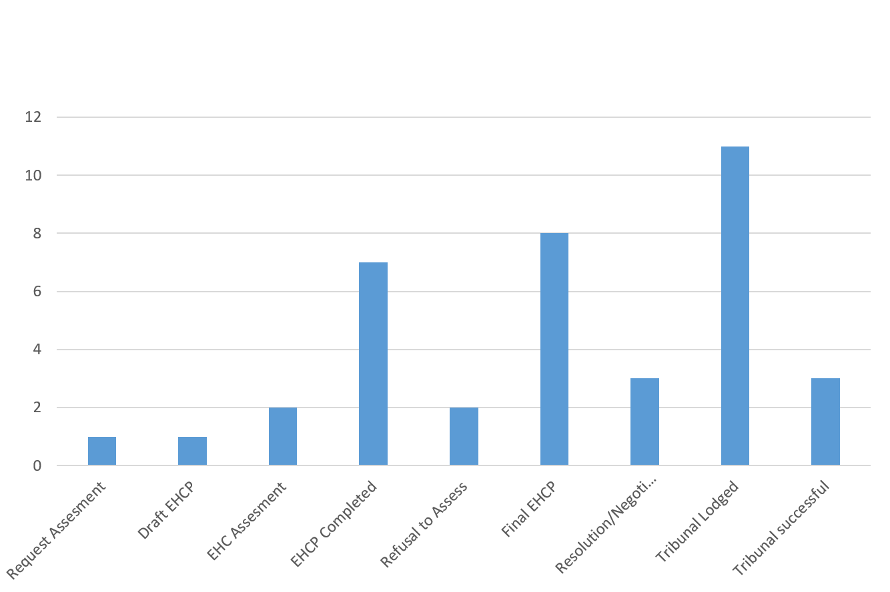



**EHCP AND SEND SUMMARY**

**School Engagement**

Our work continues in engaging with the wider community. There have been further opportunities to work with our schools across Telford. This way of working is proving to be impactful. It is really positive for us to be seen as a service that can help, guide and support , rather than being a service that historically was seen as a barrier for schools to invite . As Service lead this is in part, due to how we have promoted our offer to the schools. As a way of not only supporting parents but also how we can support schools to facilitate those engagements with families, with a more constructive and collective approach.

We have known of specific schools that in the past we have found it more challenging to engage, but have found that they are now starting to work alongside us and others to deliver SEND support for parents and also for young people, to be able to express their views ,and find some positive solutions.

This area of work continues to be a challenge for us in terms of team capacity, but we continue to prioritise this area of our work to ensure that we are accessible and have a broad reach, as evidenced by our contact with **60** parents. We need to continue to have a presence within the community.

It has proved considerably more difficult this period due to the triage line being extremely busy, and the need to ensure that parents are accessing the appropriate information in relation to the level of need and complexity. Schools we have worked with this quarter include:

Secondary Schools

Abraham Darby, Telford Langley

Primary Schools

Lightmoor, Randley, Lawley, John Fletcher (hub), Ladygrove, Grange Park.

**Appeals/Mediation**

Numbers have increased for parents wishing to appeal a LA decision. The team have been working on producing a webinar to provide information on the appeal process, how to complete the forms, and what to expect at each stage. The information will be available shortly on the website. It will provide a useful resource to signpost parents to, however we do ensure that parents are fully informed with opportunities for mediation and communication with the Local Authority as an ongoing process.

The team supported:

**8** parents to prepare the initial forms.

**4** parents during the appeal process

**1** parent to prepare for mediation

**1** appeal was resolved prior to tribunal

**3** face to face

**1** young person tribunal

**Community Drop Ins**

We have been trialing the drop in sessions to promote engagement with parents to give them an opportunity to speak individually, to a trained worker.

**SEND BiteSize Session – Lawley Community Hub**

**Donnington Hub**

**PODS Hub**

.

**Children And Young People Engagement**

Maria our CYP caseworker has supported **4**  young people individually this quarter to support their wishes and feelings in preparation for transition, annual reviews and school meetings.

Maria has also supported a young person during the tribunal process and attended the hearing. (See Case Study P. 11)

She continues her young people sessions at Abraham Darby school. A group of **11**  young people have been supported in relation to their post 16 transition working on transition , and supporting them to create their own one-page profiles ready for moving on to their new provider including what help and support will be important to them.

A one-page profile really helps both parties to get know each other, especially when moving to a new setting.

When doing one-page profiles it is good practice to put images of the young person’s interests on, so if they are having a difficult time and need to talk, staff can engage with them and show an interest in getting to know them , by talking to them about their interests.

Maria has also developed and is leading on a CYP working group at CVS, this is to enable all projects within the organisation of CVS who work with children and young people to share resources and discuss the engagement of children and young people and how they could work effectively together.

A youth development officer from the Local Authority will be coming along to the next session to find out ways that we are engaging CYP how collectively we can strengthen the voice of young people across the borough.

The team have also been involved in delivering a whole CVS staff engagement workshop to discuss the i importance of feedback to services and their knowledge and skills on different ways to gather feedback, including how to create surveys and feedback forms through MS Teams.

Maria has also attended the parish council youth worker meeting in January, this was a great networking opportunity and to share all the good work happening within the different Parishes, including potential for future funding streams to support this area of work.

We are looking at attending some of the youth clubs in the local area to talk to young people about SENDIASS and the young carers.

Post 16 provider Landau invited Maria to their SEND coffee afternoon. It was a good opportunity to discuss delivering sessions with the young people in relation to areas of their SEND needs and collecting their voices.

A request from a parent whose child attended Thomas Telford school, asked for Maria to support them to put forward their views as part of the Annual Review process, as they required someone who was independent of school.

**Elevate Youth**

As outlined earlier the Elevate Youth Sessions are a continuing success. Further sessions planned include

* Cycling sessions at the Telford Bike Hub, promoting physical activity and sustainable transport. Participants to gain greater confidence in riding and maintaining bikes.
* Collaborate with the Wrekin Housing Group to provide sessions focused on career pathways, housing advice, and preparing for adulthood. Young people will gain insights into employment opportunities and independent living options.
* School nurse delivering a session covering personal health, hygiene, and sexual health education, ensuring young people are informed, confident, and supported in making safe choices.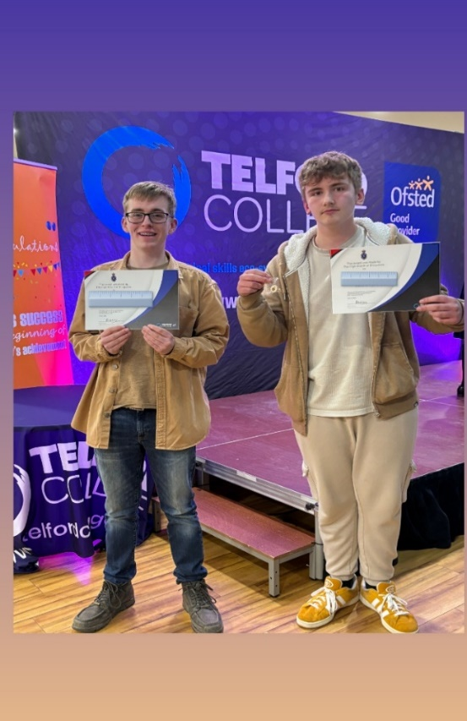

Two of our members have received awards from the High Sheriff. Joseph received the award for his Voluntary and Community work, and Bray received an award for Environmental Activities.

The young people are both volunteers within TWCVS and are both members of our Elevate Youth Group. Joe is our volunteer youth mentor and facilitates the Chess Club at the Children’s Autism Hub, whilst Bray supports members of our Elevate Youth Group and supports the further development of our children and young people engagement across TWCVS.

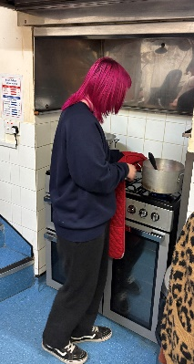We are extremely proud of them and their achievements. Well done to you both!

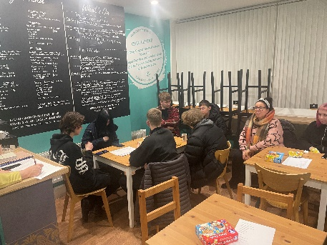

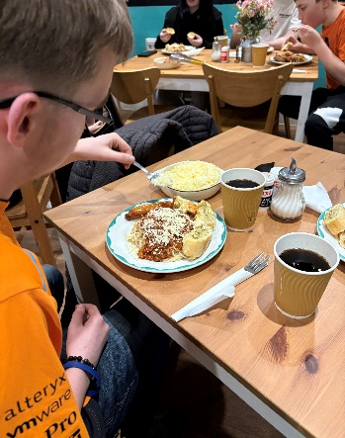

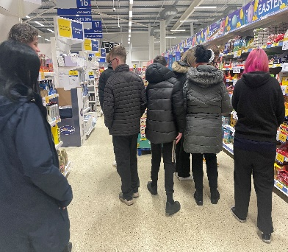

**NEW Full Client Outcomes data**

The team are now able to begin to report on the outcomes data. This is gained through the following, feedback from parents and young people face to face discussions, evaluations, case studies, throughout the various groups and individual sessions that are offered.

**Evaluation/Outcomes – Parent and Carers**

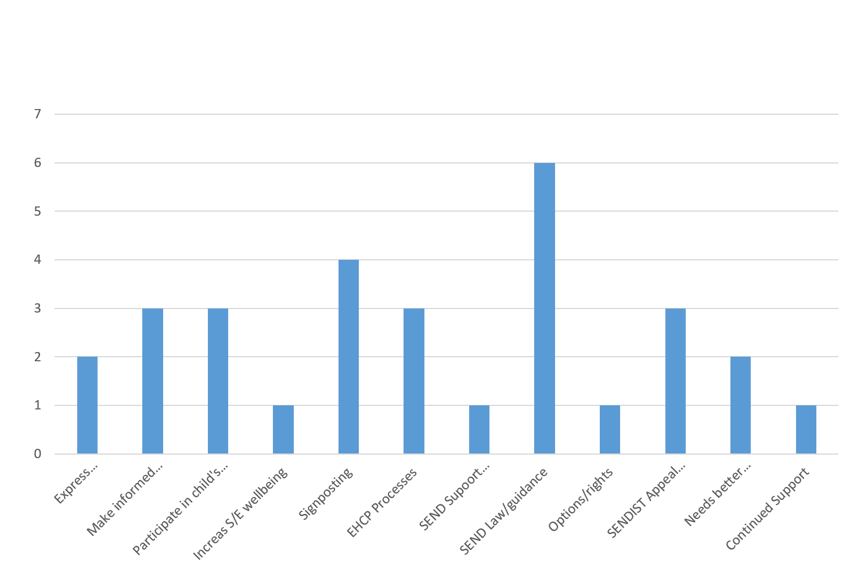

report

**Case Studies**



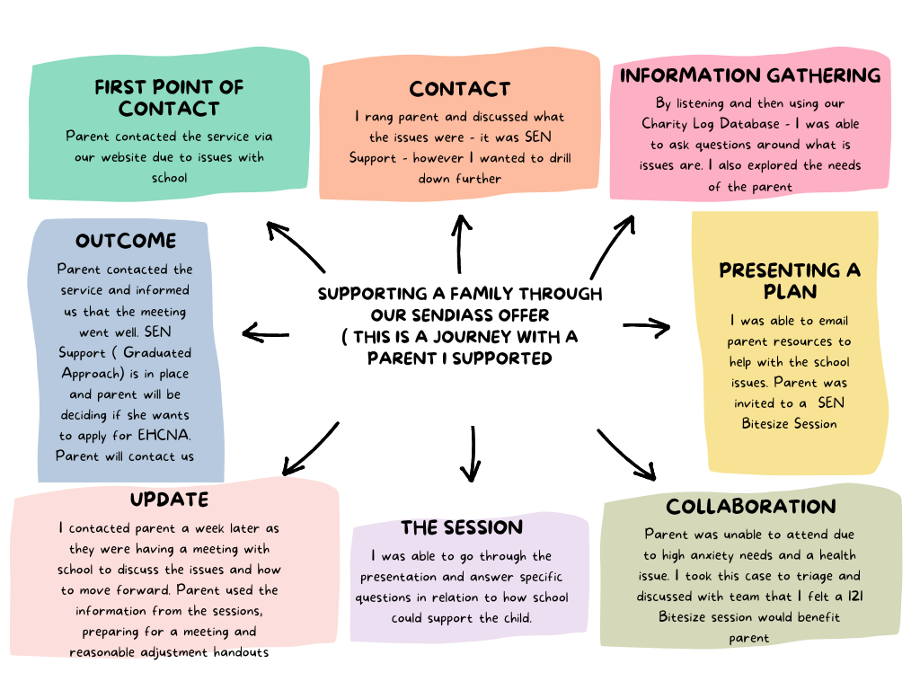



**Operational Delivery**

* Service lead continues to monitor demand/capacity. Continue to assess response time of access to service. Our response time is currently 7 days and this is communicated through our service answer machine with national helpline available and website.
* The team have been allocating time to develop the online resources. The team are currently looking at SEND areas that could benefit from having accessible webinars online. With the additional member of the team, we have been able to keep the website more up to date and we are seeing more views on our website and across our easy-to-read factsheets available , and social media posts are going out more regularly.
* Focus on SEND Support in mainstream schools. Going well. Wider engagement with parents. Focus to increase uptake of schools for SEND Workshop sessions to run alongside schools and LA where appropriate. Schools are now starting to engage with the Workshops. (Please see feedback p. 15)
* Continuing to work with wider partners to ensure good signposting when families require. We still need to strengthen our relationships and communication pathways with health and social care partners. Jo Broderick is to attend a team meeting to provide further information on short breaks offer, and thresholds for support. We now can promote our information across newsletters, websites, across health and social care. Building on relationships with local groups, Dandelions have a regular presence at drop-in sessions, we now have a space within the PODS SEND hub. Discussions are being held on holding these sessions more regularly and widening out the offer.
* Service lead to continue to build relationships with wider stakeholders and continue to support the team to identify potential funding opportunities. The team are currently applying for additional funding to further continue the “Independence ME” Project.
* Recruitment of parent volunteer role, predominantly across Childrens hub, but also supporting the joint working of the Elevate group. Our Young People Volunteers are participating in areas of development, and it is hoped that they can represent wider young people’s views through SEND and AP Partnership and Autism Partnership Boards
* Continued strategic presence through participation to ensure parent/cyp voice is fed into local SEND Developments. Increased opportunities of working together to collect voice of young people through CYP participation development group. Connections have been made with Youth Worker to support this area of development.
* Charity Log Database is now operational. Staff have been receiving ongoing training. There have been some challenges, and we are working hard to ensure that data reporting is identifying needs , impact/outcomes.

**Partnership and Strategic Development**

**Service Lead attends:**

* SENCO Network Meetings
* Attendance and updates Autism Partnership Board – Service Lead
* PFA Working Group – attended by C and YP Lead
* Parent Participation Summit Meetings
* ND Pathway Workstream
* EHCP Task and Finish Group
* SENDIASS Managers helpline forum
* Maximising Educational Capabilities – Lloyds Foundation
* PODS and IASS Communication Meetings
* SEND and AP Partnership Board Meetings
* Local Offer meetings
* SEND and IASS Team Meetings

**Staff Training/Events**

Ipsea Level 3 Training

Childrens and Adults Safeguarding Training Refresher

**SENDIASS Advisory Group Development**

Service Operational Plan 25/26 is complete. Following limited feedback. Agreement reached to revise the Groups terms of reference and send out a draft to all current members for agreement.

Changes to the group include.

* Renaming to SENDIASS Advisory Group – meetings to be held twice yearly.
* Parents entering the service are informed of the group and can opt in to become a member of the advisory group if agree. Consent to be gained. Information pack given on role of member and ways to participate.
* Updates and information will be shared across all parent members on the database.
* Invites to twice yearly Advisory group themed sessions, that will be linked to aspects of service development identified within the Service Operational Plan.
* Advisory group meetings will be working groups to collect feedback and next steps for members, parents, professionals, and representation from young people to inform and shape service development.
* Amend website information and membership form on the SENDIASS website.

This is a priority area of development.

**This piece of of work is ongoing. Will report updates through quarterly reporting.**

**UPDATE – Qtr 4**

* With the introduction of Charity Log Database, the team are informing parents of the New Advisory Group and purpose, and there is an opt out of becoming a member. The database is recording new members.
* Completion of new Terms of Reference for the group to be distributed to all existing core members.
* Information is being finalised to ensure website will be updated with new information on Advisory group., along with membership form. (This to be completed by next reporting phase)
* Service Lead has met with the Manager from Shropshire IASS. This has been beneficial. As services we are both currently further developing our Advisory Groups. Future joint working with Shropshire Service Lead, with opportunities for skill and resource sharing. Service Manager would like to attend one of our School Send Sessions to observe how we are working with schools. This is an area of development for the Shropshire Service.
* The current Service Lead will be leaving the Service and CVS Organisation , timescales for recruitment and handover have been set for 12 weeks from March 24. There will be a thorough handover including updates on operational planning and development over the coming weeks. Julie wishes to thank everyone for their continued support and collaboration , and is confident that future partnership working with continue to remain a strength in raising the profile of SEND and collectively broadening our reach across Telford and Wrekin.

**Financial – As previous quarter.**

The Service Lead continues to monitor any increased demand for the service and work with the team to identify ways to adapt the current service model to respond to those increasing demands.

We continue to identify any future funding streams, to support our community presence, support our children and young people and raise awareness of the service.

The team are increasing their visibility within community settings and schools and this way of working continues to place an increased demand on the core funding for staff travel expenses.

The budget has very limited resources to support website development. (Please see attached) Additional members of staff support this currently. There is a need to increase website resources, develop webinars. Service Lead to identify any volunteers, students who may wish to support this area of development. (ongoing).

With additional funding for the Elevate Group, IASS are able to continue to support the development of the Elevate Group to enable young people to be involved in areas that are important to them. Project began January 2025. Independence Me, shared funding and working. across Telford Childrens autism Hub. Additonal funding to continue this area of work has been processed. Awaiting outcome.

The Team Assistant role as identified through the reserve funding is a vital role to core delivery. The benefits of this role continues to be reported through contract reviews and adds value to the operational delivery of the service supporting the early identification of SEND Needs and parents receiving ias at the appropriate time to support their child. The role supports the team to build relationships with schools, update website, and support our social media platforms., and also supports administration and data retrieval. It is hoped that this area of work provides sufficient opportunity to identify those core areas of development needed to sustain the service model as we move forward through the coming months and monitoring increased demand v capacity and to be tender ready.

report

**Feedback**

“I just wanted to say thank you for your support and hard work doing the tribunal for us she now has got her echp I'm happy she now as what she needs and deserves. “

“It was really useful to have SENDIASS at school today. The parents were very complimentary, and I am hopefully that this will help them with understanding and navigating the processes of SEND. The parents seemed more confident when they left.” SCHOOL SENCO



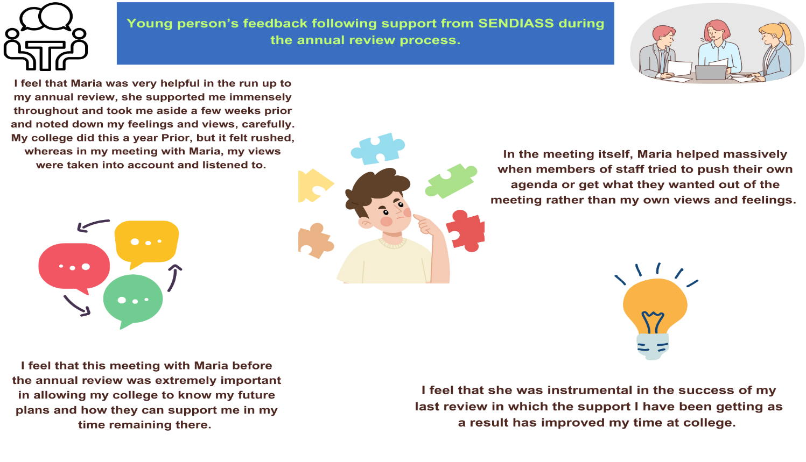

**Tribunal Feedback 2025**

<https://forms.office.com/Pages/AnalysisPage.aspx?AnalyzerToken=vZ9nkypwL8n3MIn7L6oR691Q3AFACNAW&id=vvhnBQJflkWOjxAVprfciAlfvlVDqG9FjRh4zrrBIM1UMjc0OEFFSjlZQUJMRTlHNDNUUk9NVko5Vy4u>

**Bitesize in schools**

[**https://forms.office.com/Pages/AnalysisPage.aspx?AnalyzerToken=rt99xk4ZO6Rc21KCMWGWc2vmB9jUfggz&id=vvhnBQJflkWOjxAVprfciAlfvlVDqG9FjRh4zrrBIM1UN0pPQVNPRFhQWU42WUo1SFZVT1BESzNCNi4u**](https://forms.office.com/Pages/AnalysisPage.aspx?AnalyzerToken=rt99xk4ZO6Rc21KCMWGWc2vmB9jUfggz&id=vvhnBQJflkWOjxAVprfciAlfvlVDqG9FjRh4zrrBIM1UN0pPQVNPRFhQWU42WUo1SFZVT1BESzNCNi4u)

**Coffee morning in schools**

[**https://forms.office.com/Pages/AnalysisPage.aspx?AnalyzerToken=rt99xk4ZO6Rc21KCMWGWc2vmB9jUfggz&id=vvhnBQJflkWOjxAVprfciAlfvlVDqG9FjRh4zrrBIM1UN0pPQVNPRFhQWU42WUo1SFZVT1BESzNCNi4u**](https://forms.office.com/Pages/AnalysisPage.aspx?AnalyzerToken=rt99xk4ZO6Rc21KCMWGWc2vmB9jUfggz&id=vvhnBQJflkWOjxAVprfciAlfvlVDqG9FjRh4zrrBIM1UN0pPQVNPRFhQWU42WUo1SFZVT1BESzNCNi4u)

**triage staff info:**

<https://forms.office.com/Pages/AnalysisPage.aspx?AnalyzerToken=zfX6Z8rSfAotRcR142t0tcpq300whwGN&id=vvhnBQJflkWOjxAVprfciAlfvlVDqG9FjRh4zrrBIM1UM1dNT1dSMFowSkFTMEZGVUQwV0lYNDAyRC4u>

**SEN Bitesize at office**

['SEND bite size session' QTR 4 Jan-Mar 2025.xlsx](https://twcvs-my.sharepoint.com/:x:/g/personal/info_iass_org_uk/EX7iTo7bVwxJmYN5m5cbA3sBVB4d5gk3CSP0zQjTgV09RQ?e=UuN0II)

**COMMUNITY VISITS**

[Feedback_ community visits Q4 Jan-Mar 2025.xlsx](https://twcvs-my.sharepoint.com/:x:/g/personal/info_iass_org_uk/EeCbtUrdp_9PocEiFFgcz38BJYGsAtBKPyZKEYsKWxmECw?e=olSoSW)

**Bookable 121**

[Feedback_ BOOKABLE APPOINTMENT IN COMMUNITY Q4 Jan-Mar 2025.xlsx](https://twcvs-my.sharepoint.com/:x:/g/personal/info_iass_org_uk/Ecz-mfcapTpKkBPjw5R8HtAB1dB6LHCclVGsY5CvyASq2g?e=VNOzRN)

**Website,Social Media Information**



**SENDIASS In the Community**

**Lawley SEND Coffee Morning**

**A Young Person we support participating in CVS Art Exhibition.**

**GRANGE PARK SCHOOL**

**SEN Bitesize Session**